A1375-Eur-France-Le Grand Pressigny-Hand Axe-Black Flint-Mousterian-40,000 BP

Fig. 1, Le Grand Pressigny-Hand Axe-Black Flint-Mousterian-40,000 BP

**Case no.: 1**

**Accession Number: A1375**

**Formal Label:** Le Grand Pressigny-Hand Axe-Black Flint-Mousterian-40,000 BP

**Display Description:**

This biface hand axe is of the “Mousterian of Acheulean Techno-complex” or MTA. It was made by Neanderthals, ca 50,000 BP and found in Le Grand Pressigny area. Other MTA deposits known are Fontmaure at Vellèches, Naulac at Roche-Posay and the Pyramid site at Cere-la-Ronde. **The form and execution of this extraordinary hand axe was fashioned by a Neanderthal in classic Mousterian Tradition.  Unlike their much larger predecessors of the Sahara during the Acheulian, Mousterian hand axes are much smaller in comparison.  Not only are Mousterian hand axes considered some of the rarest and most prized tools of the Neanderthals, this exquisite representation is a perfectly executed bifacial example.  A prominent proximal end knapped base rests up against the palm for comfort.  The entire surface features a rich, heavy soil sheen patina.  Superb shaping and delicate secondary flaking over faces and edges.**

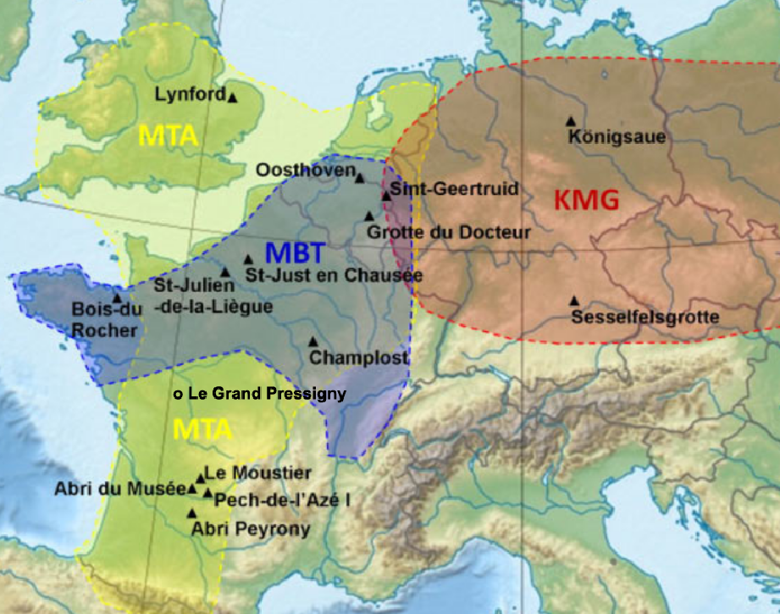

Location of the study sites and Neanderthal cultures: Mousterian of Acheulean Tradition, MTA, Keilmessergruppen, KMG, and transitional – Mousterian with Bifacial Tools, MBT (Karen Ruebens)

**GPS coordinates:** [46 ° 55 '19 "](https://translate.googleusercontent.com/translate_c?depth=1&hl=en&prev=search&rurl=translate.google.com&sl=fr&sp=nmt4&u=http://tools.wmflabs.org/geohack/geohack.php%3Flanguage%3Dfr%26pagename%3DMus%25C3%25A9e_de_la_Pr%25C3%25A9histoire_du_Grand-Pressigny%26params%3D46.921809_N_0.803508_E_type:landmark_region:FR&usg=ALkJrhgTi55y0QOKYbuJSjEaIs86gAUBfA) [,](https://translate.googleusercontent.com/translate_c?depth=1&hl=en&prev=search&rurl=translate.google.com&sl=fr&sp=nmt4&u=http://tools.wmflabs.org/geohack/geohack.php%3Flanguage%3Dfr%26pagename%3DMus%25C3%25A9e_de_la_Pr%25C3%25A9histoire_du_Grand-Pressigny%26params%3D46.921809_N_0.803508_E_type:landmark_region:FR&usg=ALkJrhgTi55y0QOKYbuJSjEaIs86gAUBfA) [0 ° 48 '13 "](https://translate.googleusercontent.com/translate_c?depth=1&hl=en&prev=search&rurl=translate.google.com&sl=fr&sp=nmt4&u=http://tools.wmflabs.org/geohack/geohack.php%3Flanguage%3Dfr%26pagename%3DMus%25C3%25A9e_de_la_Pr%25C3%25A9histoire_du_Grand-Pressigny%26params%3D46.921809_N_0.803508_E_type:landmark_region:FR&usg=ALkJrhgTi55y0QOKYbuJSjEaIs86gAUBfA). 46.920000: 0.806000E

**Cultural Affiliation:** Mousterian

**Medium:** flint

**Dimensions:**

**Weight:**

**Condition: original**

**Provenance:**

**Discussion:**

**A study of 1,300 stone hand axes found at 80 Neanderthal sites in France, Germany, Belgium, Britain and the Netherlands shows that two** separate hand axe traditions or designs existed – the Mousterian of Acheulean Tradition (MTA) in a region now spanning south-western France and Britain and the Keilmessergruppen Tradition in Germany and further to the East **between 115,000 to 35,000 BP**  according to study author Dr Karen Ruebens from the University of Southampton, who [reported the results in the *Journal of Human Evolution*](http://www.sciencedirect.com/science/article/pii/S0047248413001474). She also identified an area covering modern day Belgium and the Netherlands that demonstrates a transition between the two.“In Germany and France there appears to be two separate hand axe traditions, with clear boundaries, indicating completely separate, independent developments,” Dr Ruebens commented.“The transition zone in Belgium and Northern France indicates contact between the different groups of Neanderthals, which is generally difficult to identify but has been much talked about, especially in relation to later contacts with groups of modern humans.”“This area can be seen as a melting pot of ideas where mobile groups of Neanderthals, both from the eastern and western tradition, would pass by – influencing each other’s designs and leaving behind a more varied record of bifacial tools.”Neanderthals in the western region made symmetrical, triangular and heart-shaped hand axes, while during the same time period, in the eastern region, they produced asymmetrically shaped bifacial knives.

[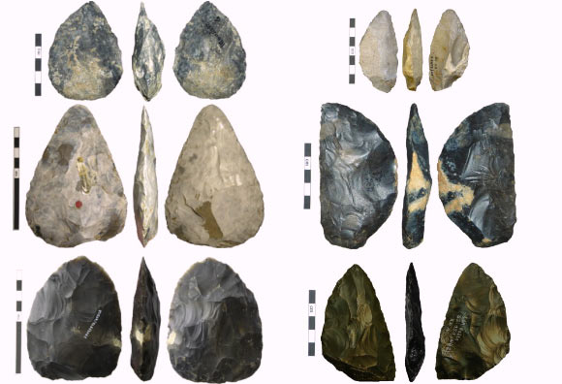](http://cdn.sci-news.com/images/enlarge/image_1322_2e-Neanderthals.jpg)

Left: Mousterian of Acheulean Tradition (MTA) hand axes, from top to bottom – cordiform hand axe from Le Moustier, France; triangular hand axe from St. Just en Chaussée, France; hand axe from Lynford, UK (Karen Ruebens). Right: Keilmessergruppen Tradition hand axes, from top to bottom – keilmesser from Sesselfesgrotte, Germany; keilmesser from Abri du Musée, France; faustkeilblatt from Königsaue, Germany (Karen Ruebens).

“Distinct ways of making a hand axe were passed on from generation to generation and for long enough to become visible in the archaeological record. This indicates a strong mechanism of social learning within these two groups and says something about the stability and connectivity of the Neanderthal populations,” Dr Ruebens said. “Making stone tools was not merely an opportunistic task. A lot of time, effort and tradition were invested and these tools carry a certain amount of socio-cultural information, which does not contribute directly to their function.” The analysis also reveals other factors which could have influenced hand axe design, such as raw material availability to Neanderthals, the function of their sites, or the repeated reuse and sharpening of tools. The study adds a new archaeological perspective on Neanderthal regionality, which is a concept also identified in studies of their skeletal and genetic features.

______

**References:**

Rueben, Karen. 2013. “Regional behaviour among late Neanderthal groups in Western Europe: A comparative assessment of late Middle Palaeolithic bifacial tool variability,” *Journal of Human Evolution*, published online August 6, 2013; doi: 10.1016/j.jhevol.2013.06.009